Pizza Shop Revenue Analysis
KPI’s:
Total Revenue:

- select sum(total_price) as Total_Revenue from [pizza_sales_excel_file (1)]

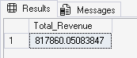

Average Order Value:

- select sum(total_price)/count(distinct order_id) as Avg_Order_Value from [pizza_sales_excel_file (1)]

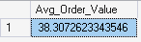

Total Pizzas Sold:

- select sum(quantity) as Total_Pizzas_Sold from [pizza_sales_excel_file (1)]
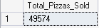

Total Orders Placed:

- select count(distinct order_id) as Total_Orders from [pizza_sales_excel_file (1)]

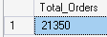

Average Pizzas Per Order:

- select cast(cast(sum(quantity) as decimal(10,2))/Cast(count(distinct order_id) as decimal(10,2)) as decimal(10,2)) as Average_Pizzas_Orderd from [pizza_sales_excel_file (1)]

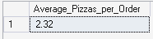
All Queries Used:

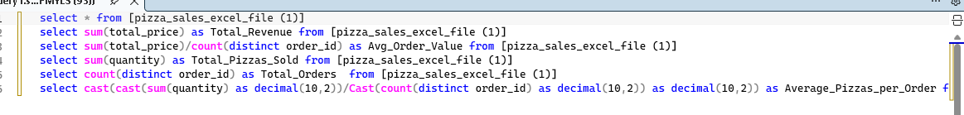
Daily Trend Chart:

- Select DATENAME(DW,order_date) as order_day, count(distinct order_id) as Total_Orders from [pizza_sales_excel_file (1)]
Group BY DATENAME(DW,order_date)

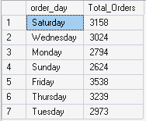

Monthly Trend Chart:

- select DATENAME(MONTH,order_date) as Month_Name, count(distinct order_id) as Total_Orders from
[pizza_sales_excel_file (1)]
Group BY DATENAME(MONTH,order_date)

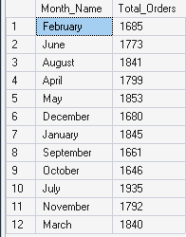

Total Pizzas Sold by Category:

- select pizza_category,sum(total_price) as Total_sales, sum(total_price) * 100/ (select sum(total_price) from [pizza_sales_excel_file (1)] ) as PCT
from [pizza_sales_excel_file (1)]
Group By pizza_category

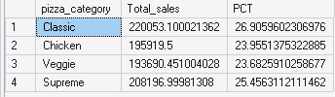
Total Pizzas Sold by Size:

- select pizza_size,sum(total_price) as Total_sales, sum(total_price) * 100/ (select sum(total_price) from [pizza_sales_excel_file (1)] ) as PCT
from [pizza_sales_excel_file (1)]
Group By pizza_size
Order By PCT DESC

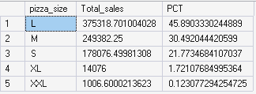

Top 5 Selling Pizzas:

- select Top 5 pizza_name , sum(total_price) as Total_Revenue from [pizza_sales_excel_file (1)]
Group By pizza_name
Order By Total_Revenue DESC

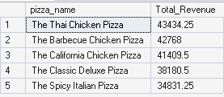

Top Least Selling Pizzas:

- select Top 5 pizza_name , sum(total_price) as Total_Revenue from [pizza_sales_excel_file (1)]
Group By pizza_name
Order By Total_Revenue ASC

